The Soil is Breathing! Student Handout Engagement Phase

**Name: ___________________________ Date: ____________________________**

**The Importance of Earthworms for Soil Structure–I Notice, I Wonder, It Reminds Me Of**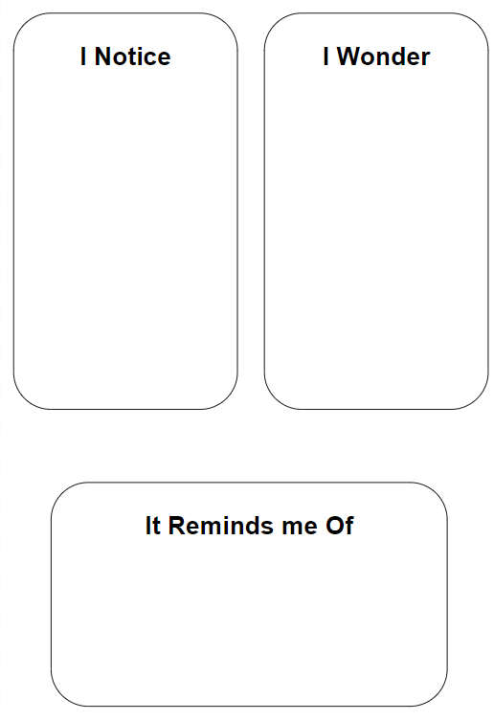

Read the provided article. As you read, make observations and complete the graphic organizer.

The Soil is Breathing! Student Handout Explore Phase

**Name: ___________________________ Date: ____________________________**

**The Soil is Breathing!**

**Investigation Procedure:**

1. Fill each bottle about ⅔ full of soil then add water to moisten. Use tape and a marker to label each bottle with the appropriate soil sample.
2. Place a balloon over the opening of each bottle and secure it with a rubber band.
3. Observe the soil samples over time, watching for the balloon to rise. In 5 minute intervals, record what is happening with each sample’s balloon.

The Soil is Breathing! Student Handout Explore Phase

**The Soil is Breathing! Data Sheet**

|  | Sample 1 | Sample 2 | Sample 3 | Sample 4 |
| --- | --- | --- | --- | --- |
| 5 minutes |  |  |  |  |
| 10 minutes |  |  |  |  |
| 15 minutes |  |  |  |  |
| 20 minutes |  |  |  |  |
| 30 minutes |  |  |  |  |
| 40 minutes |  |  |  |  |
| 45 minutes |  |  |  |  |

**Which soils have more organisms?**

Based on the data you’ve collected, answer the question in the claim, evidence, reasoning format.

**Claim** (Your claim should be one or two sentences that clearly and simply answer the question.)

**Evidence** (Provide specific evidence from your observations.)

**Reasoning** (Explain why your evidence supports your claim.)

The Soil is Breathing! Student Handout Elaborate Phase

**Name: ___________________________ Date: ____________________________**

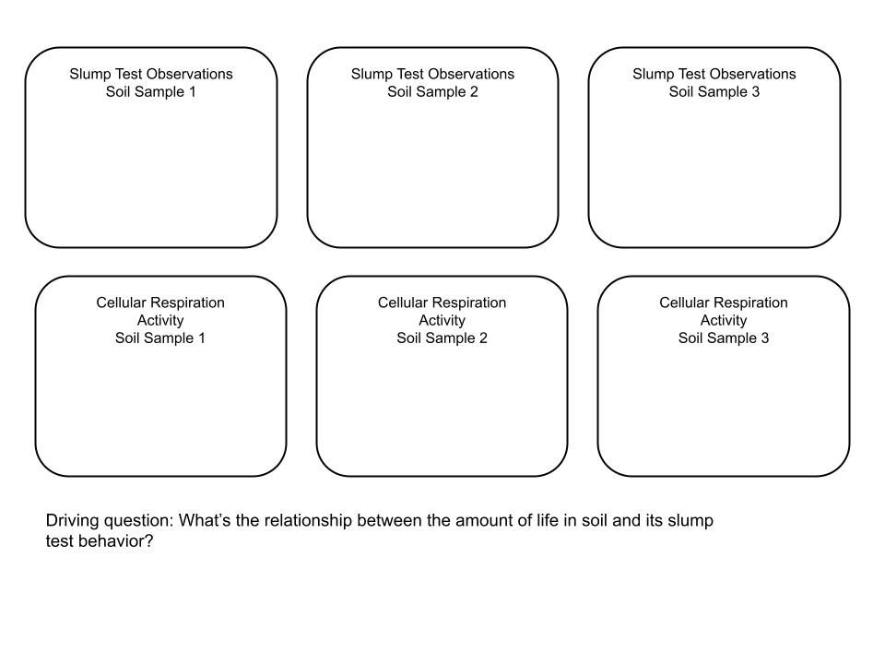

Working from your observations on the handout, choose a creative project to make sense of and report what you figured out about the relationship between the organisms in soil samples and slump test behavior. Each project should answer the driving question, provide evidence to support the answer, and provide scientific reasoning as to why the evidence supports the answer.

Some projects to choose from may include: a comic book or comic strip, a children’s book, an infographic or a video. Your project will be scored using this rubric:

CHOICE ASSIGNMENT RUBRIC

|  | Excellent | Proficient | Approaching | Below |
| --- | --- | --- | --- | --- |
| Science Content  (60 points) | * Accurate based on the investigation * Completely answers the question * The data are scientifically appropriate to support the claim * The data are complete and convincing – sufficient details and evidence provided * Uses appropriate scientific principles to shows why the data support the claim   **Scientific principles need not use academic language at this point, evaluate based on your understanding of the students’ content knowledge.  (60 points) | * Accurate based on the investigation * Nearly completely answers the question * The data are scientifically appropriate to support the claim * The data are mostly sufficient and convincing, but are somewhat general, lacking specificity and depth * Includes related scientific principles, but only passably demonstrates why the data support the claim * Reasoning is general and shows partial depth of content understanding   (45 points) | * Partially accurate based on the investigation * Partially answers the question * The data relate to the claim, but are not entirely scientifically appropriate * The data are insufficient, though generally support the claim * Does not demonstrate why the data support the claim * Shows little depth of content understanding | * Is not accurate overall * Does not adequately answer the question * There is some evidence provided, but it is not logically linked to the claim or scientifically appropriate * The evidence provided is not based on the investigation * Scientific understanding is very limited   (0 points) |
| Visual Support  (20 points) | 5 or more visuals are included that support the assigned content.  (20 points) | 3-4 visuals included that support the assigned content. Some visuals that do not support the assigned content or are distracting from the main ideas.  (15 points) |
| Quality of Content  (20 points) | Grammar in spoken or written words is accurate. A maximum of one mistake.  Product is  visually appealing - fonts and/or handwriting are readable.  Any sounds included can be heard clearly, are appropriate, and support the assigned content.  (20 points) | 2-3 Grammar mistakes.  Fonts and/or handwriting are fair.  Sounds could be clearer or do not fully support the content.  (15 points) |