**Teacher Handout–Slake Testing**

Guidelines for NGSS 3-Dimensional Learning

**NGSS Alignment:** MS-ESS2: Earth and Human Activity, HS-ESS2: Earth and Human Activity

**Performance Expectations:**

* MS-ESS3-3 Apply scientific principles to design a method for monitoring and minimizing a human impact on the environment.
* HS-ESS3-4 Evaluate or refine a technological solution that reduces impacts of human activities on natural systems.
* HS-ESS2-2 Analyze geoscience data to make the claim that one change to Earth's surface can create feedbacks that cause changes to other Earth systems.

**MS-ESS3.C: Human Impacts on Earth’s Systems**

**●** [Typically as human populations and per-capita consumption of natural resources increase, so do the negative impacts on Earth unless the activities and technologies involved are engineered otherwise.](http://www.nap.edu/openbook.php?record_id=13165&page=194)

### [**ESS3.C: Human Impacts on Earth Systems**](http://www.nap.edu/openbook.php?record_id=13165&page=194)

* [Scientists and engineers can make major contributions by developing technologies that produce less pollution and waste and that preclude ecosystem degradation.](http://www.nap.edu/openbook.php?record_id=13165&page=194)

### [**ETS1.B: Developing Possible Solutions**](http://www.nap.edu/openbook.php?record_id=13165&page=175)

* [When evaluating solutions, it is important to take into account a range of constraints, including cost, safety, reliability, and aesthetics, and to consider social, cultural, and environmental impacts. *(secondary)*](http://www.nap.edu/openbook.php?record_id=13165&page=206)

**Science and Engineering Practices:**

* Constructing Explanations and Designing Solutions.
* Analyzing and Interpreting Data

**Crosscutting Concepts:**

* Cause and Effect

**Alignment to Illinois Career Tech Courses:**

* Basic Environmental Science
* Crop Science
* Environmental Science
* Introduction to the Agricultural Industry
* Precision Agriculture
* Soil Science
* Specialty Crop Production
* STEM in AFNR

**Overall lesson objective:**

Using the anchoring phenomenon of the Slake Test, students make observations and write questions. Leveraging their questions, students construct a hypothesis about the impact of various soil characteristics on the ability to slake, make observations of soil samples to collect and analyze data to answer their question, communicate their findings in writing, and then apply what they learned to make sense of claims about various soil conservation practices.

**Accommodations for students on IEPs and ELL students:**

Provide additional explanations on directions to ELL students or students on IEPs. Allow students to dictate written work to a teacher or paraprofessional.

**Teacher Handout Engagement Phase**

***Slake Test Demonstration Activity***

**Purpose of Slake Test Activity:** The purpose of Slake Test Demonstration and the questioning activity that follows is to introduce students to slake testing and engage them in thinking about what is happening in the test. Students observe the instructor carrying out a slake test.

**Learning Objective Addressed in Slake Test Demonstration Activity:** Using a slake test as an anchoring phenomenon, students identify questions about differences among soil samples as observed during the slake test.

**Driving question**: What characteristics of soil impact its behavior in a slake test?

**Overview ofSlake Test Demonstration Activity:** Students observe their instructor carrying out a slake test. Alternatively, students may work in groups to carry out slake tests. While watching the demonstration, students make observational notes and write questions in the “What Do I Notice, What Do I Wonder” chart. Working in small groups, students rewrite closed questions (yes or no, only one definitive answer) to make them open (requiring an explanation because there may be multiple answers). Then, the students rank the group’s questions in order of importance. Finally, the teacher leads the class as they create a driving question board.

**Time:** One 50-minute class period

**Background:**

Aggregate stability is an important indicator of soil health and is useful for evaluating the impact of various soil management practices. Importantly, aggregate stability influences how well water is able to infiltrate, how the soil reacts to disturbances like heavy rainfall, and plant health, and nutrient cycling (Flynn, 2019; Soil health technical note).

The slake test is useful for demonstrating aggregate stability. If large pores within the soil are stable, water will move into the soil sample without causing it to slake, or break apart. Conducting slake tests on various soil samples allows students to compare their stability.

**Materials:**

*Student materials:*

● Engage Student Handout: *Slake Testing*

*Teacher materials:*

● Slake Testing Kit

* [Slake Testing Slide Deck](https://docs.google.com/presentation/d/1slJ-1HNV2Av2Z_-ur2h8Y05m8U_v82goacWZJMsiKUQ/edit?usp=sharing)
* Soil samples (It is ideal to take samples from fields under different management strategies if possible: conventional, no-till, cover crops, etc.; alternatively, samples may be taken from tilled fields and untilled areas like fencerows.)
* Engage Teacher Handout: *Slake Test Demonstration Activity*

● Driving Question Board materials may include

○ White board or chalk board

○ Presentation boards with Post-it Notes

○  [Jamboard](https://edu.google.com/products/jamboard/), shared Google drawing or other collaborative technology

**Set-up:**

Before class, set up a driving question board. As mentioned above, there are several options for the Driving Question Board.

● White board / chalk board: Divide the board into sections for each category of question generated during the whole group discussion. Post the questions in the appropriate section or post student questions on sticky notes in each section.

● Presentation boards / post it notes: Prepare one presentation board for each class period. Divide the board into sections for each category of question generated during the whole group discussion. Post students’ questions on sticky notes in the appropriate sections.

● Online collaboration tool: Create an online collaboration tool (one per class period) such as a Jamboard (Figure 1) or a shared Google drawing. Share with students, giving them editing privileges.

**Procedure--Part I--Demonstration, Observations, and Initial Questions:**

To introduce the lesson’s anchoring phenomena, students observe a slake test (or carry out one themselves with instruction from the instructor) on a variety of soil samples; students should not be told the sources of these samples at this point in the lesson. Instructions for carrying out a slake test are available on [this handout](https://drive.google.com/file/d/1GbPyLUsDkbxhxGy0abkD8W1Rec_nFVdS/view?usp=drive_link). While watching the demonstration, students record observations on the *Slake Testing* hand-out. After the video, give students 2-3 minutes to write down what they observed while watching the demonstration that interested them. Next, provide students with about five minutes to generate three questions they have about the content in the demonstration. Encourage students to base their questions on observations: what they saw, what they learned, and what they wonder from the demonstration.

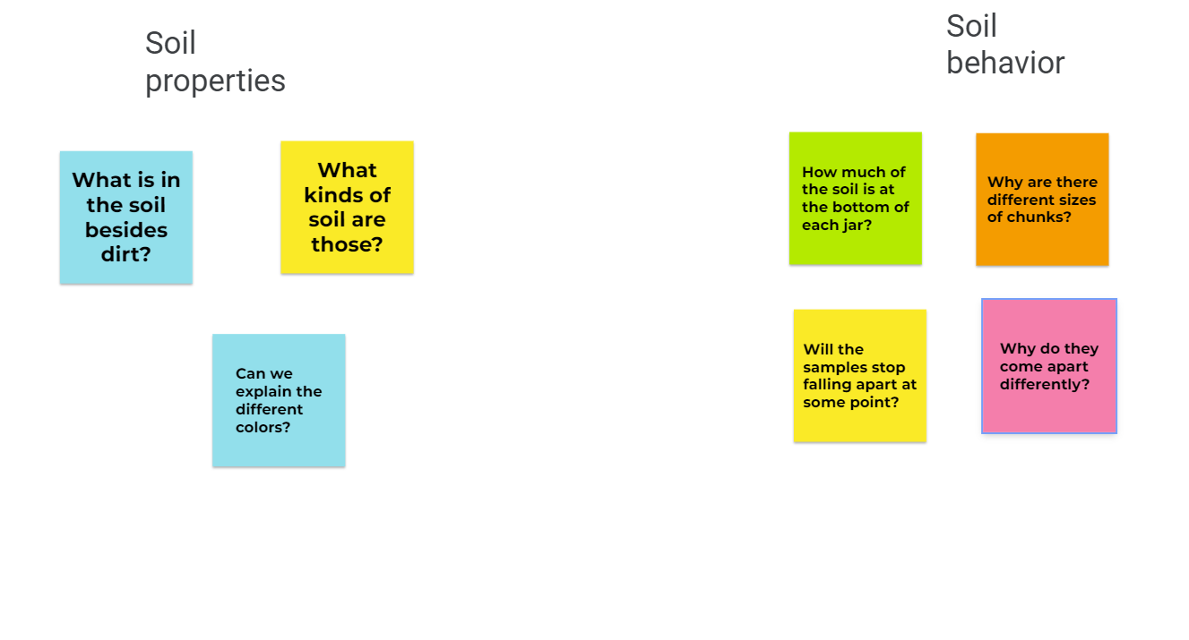

**Figure 1** This Driving Question Board was created on Jamboard.

**Procedure--Part II--Driving Question Board and Transition to Explore:**

Arrange students in small groups. Provide groups 10-15 minutes to discuss each group member’s questions, and for the group to work together to rewrite any closed questions (yes or no, only one definitive answer) to make them open (requiring an explanation because there may be multiple answers) and rank their questions in order of importance. Students should be prepared to share their questions with the whole class.

*Note: Here, I participate in the small group discussions to facilitate students in writing open questions and guiding students toward choosing questions that relate to relationships between algae and their ecosystems. I also stress that questions are not wrong if they are different and use the opportunity to discuss how science is advanced through different ideas which are rooted in each person’s unique background and understanding.*

During a whole class discussion, students contribute to the creation of the lesson’s driving question for the Driving Question Board (**Figure 1**) by adding their three top questions to the board (writing a question on the board, adding a sticky note, or adding to the shared collaboration tool like Jamboard or a Google drawing). As questions are added to the Board, the class works together to sort the questions into categories such as causes of the algal bloom, effects on the ecosystem, phosphorus, human impacts on the algal bloom, or improving the algal bloom issue.

The question board remains on display throughout the lesson, to guide students as they develop the question their group is interested in investigating in the Exploration phase. To transition into the Exploration phase, I say, “I see that many of your questions center on characteristics of the soil and how it acts in the water. So, considering your observations, think about this question, ““What characteristics of soil impact its behavior in a slake test?”.” Tomorrow, we will begin looking for an answer.”

**Teacher Handout Explore Phase**

***Soil Sample Observation***

**Purpose of Soil Sample Observation Activity:** The purpose of this activity is to increase students’ efficacy in gathering and analyzing soil data.

**Learning Objective Addressed in Soil Sample Observation Activity:** Students explore and make observations of a variety of soil samples, working methodically to make detailed visual and tactile observations.

**Driving question**: What characteristics of soil impact its behavior in a slake test?

**Overview of Soil Sample Observation Activity:** Students will work methodically, using various tools, to make both visual and tactile observations of a variety of soil samples.

**Time**

● 1-50-minute class period

**Materials**

Each group will need:

* Multiple soil samples from fields employing different soil management methods (conventional, no-till, etc.); these should be from the same sources as those used in the slake test demonstration
* Garden trowel
* Sieve or screen
* Probe (a wooden skewer or similar will suffice)
* Magnifying glass
* Boxes or plastic tubs for samples (2 per sample)
* A small bowl of water

**Procedure:**

Students make visual observations of the soil one layer at a time, working from top to bottom. As they assess each layer, students use the garden trowel to remove that layer and expose the next. Discarded soil is placed in a box or tub.

As students explore, they record their observations on the Student Handout: Soil Sample Observation. Advise students to pay attention to color, texture, the various components of the soil such as stones, biological matter, sand, clay, etc.), and pores or spaces in the soil. Students may use probes, sieves, and magnifying glasses as they see fit for their observations. For each layer, students will also make tactile observations of the soil by dampening a small handful and rubbing it between their fingers.

**Teacher Handout Explain Phase**

***Claim, Evidence, Reasoning Writing Activity***

**Purpose of Claim, Evidence, Reasoning Writing Activity:** The purpose of the Claim, Evidence, Reasoning Writing Activity is for students to develop skills in analyzing evidence and constructing explanations.

**Learning Objective Addressed in Slake Test Demonstration Activity:** Comparing their observations from the slake test demonstration and the soil observation activity, students will draw conclusions and develop an explanation for which soil characteristics impact soil behavior in a slake test.

**Driving question**: What characteristics of soil impact its behavior in a slake test?

**Overview ofClaim, Evidence, Reasoning Writing Activity:** Thinking back to the Slake Test Demonstration and the Soil Sample Observation activity, students compare the observations made during the slake test with the observations you made of the soil samples. Students answer the driving question using the Claim, Evidence, Reasoning Format.

**Time:** One 50-minute class period

**Materials:**

* Claim, Evidence, Reasoning Writing Activity Student Handout
* Claim, Evidence, Reasoning Slide Deck

**Procedure:**

Introduce students to the Claim, Evidence, Reasoning writing format using [the provided slide deck](https://docs.google.com/presentation/d/13cIgasiTNdunnsCalhCPZWJ7wCN-9T_MOaG3veQhx8w/edit?usp=sharing). Give students time to construct their responses. You may wish to allow students to peer edit before submitting their work. After work is submitted, evaluate their responses with the [provided rubric](https://docs.google.com/document/d/1o_UVSOC55mOLS2s4CrEOB9O-Aggqa4S8LZAMLa5Och0/edit?usp=sharing).

As students develop writing skills in this method, it is helpful to provide written comments and allow them to resubmit new drafts. Frequent feedback may include:

* Your claim should clearly answer the question asked.
* Provide specific evidence based on the observations you made in the activities.
* Your reasoning should explain *why and how* the evidence you provided backs up your claim.

**Teacher Handout Elaboration Phase**

**Purpose of Agriculture News Activity:** The purpose of the Agriculture News Activity is for students to develop skills in analyzing written text, looking for evidence, and comparing and contrasting work from varied viewpoints.

**Learning Objective Addressed in Agriculture News Activity:** Compare and contrast two nonfiction agriculture news articles and summarize the differences in perspective and hypothesis.

**Driving question**: What methods can impact soil conservation?

**Overview ofAgriculture News Activity:** Students read two articles about no-till farming, written from two different perspectives. They use a graphic organizer to make notes as they read, then discuss their reading with small groups. Finally, students will choose a creative method for bringing awareness about the topic to a wider audience (blog post, video ad, or letter to a legislator).

**Time:** Two or three 50-minute class periods

**Materials:**

* Digital or printed copies of the two articles for each student
* Article analysis graphic organizer
* Article analysis slide deck
* Article analysis rubric

**Procedure:**

* Introduce the activity with the [provided slide deck](https://docs.google.com/presentation/d/14yZzy6_YwVJ4NrShmUXi9t2dA_4hoXvu2o6NTBvBnOU/edit?usp=sharing), slides 1-3.
* Give students time to read the two articles provided and complete their graphic organizers.
* As a whole class, discuss appropriate academic conversation, using slide 5 as a guide; provide this slide as a reference for students moving forward.
* Give students time to discuss their findings in small groups, using slide 6. You may consider giving students a specific talk structure to use such as round robin, think pair share, etc.
* Assign students the creative portion of the lesson (slide 7). You may consider providing students with examples of each option.
* Evaluate student work using the [provided rubric.](https://docs.google.com/document/d/1nNgwkArPSaOLHPIhumlnm5Xpk7W3Xeg0w2NPu5eYYYo/edit?usp=sharing)

**Teacher Handout Evaluation Phase**

The lesson includes multiple opportunities for assessment to monitor students’ understanding of both science content knowledge and scientific practices. In the Explore phase, students demonstrate their ability to make and record careful observations. In the Explain phase students demonstrate their ability to use data to support a claim. As the lesson’s summative assessment, students write a reflection on two different articles related to soil health, demonstrating their ability to synthesize information and make judgements about claims. This array of assessments is designed to meet the needs of students’ diverse academic strengths.

References

Flynn, K. D., Bagnall, D. K., & Morgan, C. L. (2020). Evaluation of SLAKES, a smartphone application for quantifying aggregate stability, in high‐clay soils. Soil Science Society of America Journal, 84(2), 345-353.